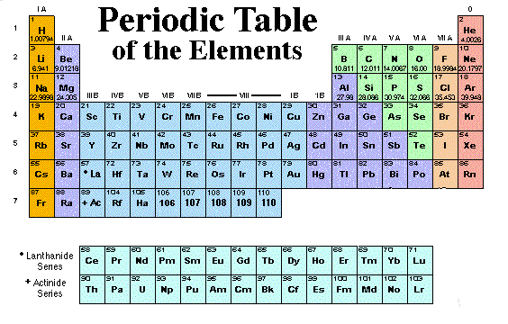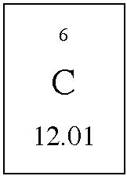

Review of Ch. 1 Elements and Compounds

- Knowledge can be classified as empirical (observable) or theoretical (based on ideas).

1. Classify the following statements as examples of empirical or theoretical knowledge.

Atoms and ions were rearranged. ________________________
A yellow precipitate formed. ________________________

- Matter can be classified as pure substances (elements or compounds) and homogeneous or heterogeneous mixtures.

2. Classify the following entities as an element, compound or mixture.

sucrose _______________ palladium _______________ milk _______________

- The Periodic Table organizes the known elements by horizontal rows called periods and by vertical columns called groups or families.

3. The family of elements listed in Group 2 of the periodic table are the ___________________.
4. The family of elements that are soft, silver-colored conductors of electricity that react violently with water and form 1⁺ ions are the _______________________.
5. The halogen family includes non-metal elements that are very reactive and form ______ ions.

- Atomic Theories explain the periodic table and describe the structure of atoms.

6. Lead has _____ occupied energy levels and _____ valence electrons.
7. The radioactive isotope of carbon, carbon-14, has ___ protons, ___ electrons and ___ neutrons.
8. Write the isotope notation for lithium-7.

9. Draw energy-level diagrams to represent the reaction of magnesium and oxygen to form
magnesium oxide.

10. Give the name and symbol for an entity containing 80 electrons and 82 protons.

11. Complete the following table.

Symbol | Name | # protons | # electrons | Net Charge
 | sulfide ion
 |  | 35 | 36
Ca²⁺
 |  | 23 | 23
 |  | 26 |  | 3⁺
 |  |  | 18 | 0

- Ionic Compounds contain metals and non-metals and are formed when a positive cation is strongly attracted to a negative anion with an ionic bond produced by a transfer of electrons.

12. Write an unbalanced chemical equation from the following word equation:
sodium oxalate + calcium hydroxide → calcium oxalate + sodium hydroxide

13. Write a word equation using IUPAC names for the following chemical equation:
NiS(aq) + Al(NO₃)₃(aq) → Ni(NO₃)₂(aq) + Al₂S₃(s)

14. The IUPAC name for FeSO₄•7H₂O(s) is _________________________________________.

- Molecular Compounds contain only non-metal atoms held together by covalent bonds produced by a sharing of electrons.

15. Provide the chemical formulas with states of matter for the following molecular substances.
chlorine __________ phosphorus __________
sulfur dioxide __________ methane __________
ammonia __________ dinitrogen tetraoxide __________

16. Write a word equation using IUPAC names for the following chemical equation:
C₂H₅OH(l) + O₂(g) → CO₂(g) + H₂O(g)

Review of Ch. 2 Chemical Reactions

- Most STS issues can be discussed from many points of view, or perspectives, such as the five
“STEEP” perspectives:
-Scientific dealing with research and explanation of phenomena
-Technological concerned with the use of machines, instruments and processes
-Ecological considers relationships between living organisms and the environment
-Economic focuses the production, distribution and consumption of wealth
-Political involves vote-getting actions and measures

17. Classify the perspective demonstrated by the following statement – “Extensive studies have
found that dioxins are among the most persistent pollutants on Earth and have been found in the
tissues of polar bears, seals, tropical birds, dolphins and humans.”
_______________________

- Kinetic molecular theory (KMT) and collision reaction theory can be used to explain how chemical reactions occur and balanced chemical equations can be written to describe reactions.

18. Changes in matter can be classified as physical, chemical or ___________________ changes.

19. Use whole number coefficients to balance the following chemical reaction:
____C₃H₈(g) + ____O₂(g) → ____CO₂(g) + ____H₂O(g)

20. Write a balanced chemical equation for the reaction of calcium chloride solution with sodium phosphate solution to produce a precipitate of calcium phosphate and aqueous sodium chloride.

- The mass of a substance measured in grams can be converted into a chemical amount in moles using the molar mass as a conversion factor.

$n= \frac{m}{M}$ or m = n M

21. Calculate the mass of fuel burned when an alcohol lamp burns 2.50 mol of methanol.

22. Determine the chemical amount of ammonium sulfate fertilizer in a mass of 150 g.

- The 5 most common types of chemical reactions include:

i) formation (elements → compound)
ii) simple decomposition (compound → elements)
iii) combustion (fuel + oxygen → most common oxides)
iv) single replacement (element + compound → element + compound)
v) double replacement (compound + compound → compound + compound)

- The solubility of ionic compounds formed in single and double replacement reactions can be predicted using the solubility table on page six of the data booklet. Molecular fuels and all elements except chlorine have low solubility in water.

23. Complete and balance the following chemical reactions and identify each as one of the five main types of reactions.

a) Al₂O₃(s) →

b) C₈H₁₈(l) + O₂(g) →

c) Cu(NO₃)₂(aq) + NaOH(aq) →

d) Fe(s) + Br₂(l) →

e) Al(s) + ZnSO₄(aq) →

24. Write the chemical formula of the following substances including a state of matter that describes the solubility of each in pure water.

a) sucrose e) ammonium nitrate

b) methane f) sulfur

c) calcium sulfate g) ammonia

d) carbon h) chlorine

