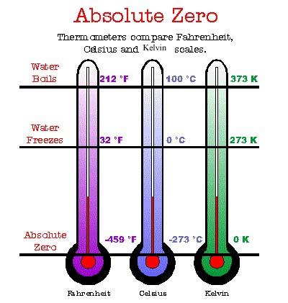
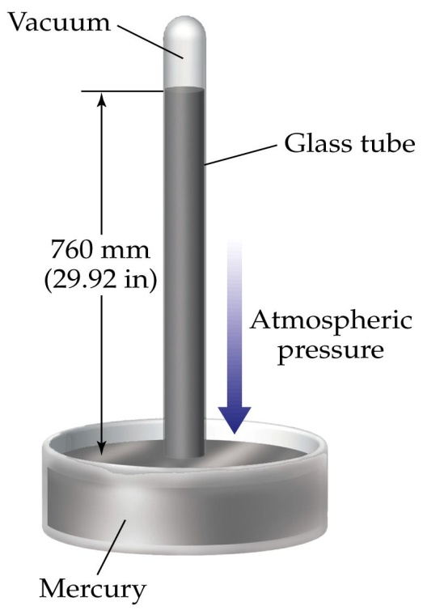

Review of Ch. 4 Gases

- Pressure of a gas is defined as the force per unit area exerted when gas particles strike the wall of a container and Atmospheric Pressure is the force exerted by air on all objects.

1 atm = 101.325 kPa = 760 mm of Hg

1. Complete the following table of pressure units.

Pressure  (kPa) | Pressure  (atm) | Pressure  (mm Hg)
 | 0.0825
75.0
 |  | 834

- Boyle’s Law states that there is an inverse relationship between pressure and volume of a gas assuming that temperature and amount of gas remain constant.

P₁V₁ = P₂V₂

2. A bicycle pump contains 250 mL of air at a pressure of 102 kPa. Determine the new volume if the pump pressure is increased to 210 kPa.

3. A diving bell contains 45 kL of air at a pressure of 97.5 kPa when floating at the surface. At 5m below the surface, the volume of air inside the bell decreases to 28 kL. Calculate the new pressure of the air in the bell.

- The Kelvin Temperature defines the coldest possible temperature as absolute zero with a value of 0 K which is equivalent to −273°C.

Kelvin = Celsius + 273 or Celsius = Kelvin − 273

4. Standard ambient temperature (SATP) in Kelvins is equal to _______________.

5. The boiling point of pure water at sea level measured in Kelvins is ______________.

- Charles’ Law states that there is a direct relationship between volume of a gas and its temperature in Kelvins assuming that pressure and amount of gas remain constant.

$$\frac{V_{1}}{T_{1}} = \frac{V_{2}}{T_{2}}$$

6. A party balloon containing 3.5 L of air is taken from inside a house at 22°C to the outdoors where the temperature is −15°C. Determine the new volume of the balloon.

7. A student buys a 4.0 L party balloon in a store where the inside temperature is 23°C. When taken outside, the balloon shrinks to 3.5 L. Predict the outside Celsius temperature.

- Combined Gas Law states that the product of the pressure and volume of a gas is directly proportional to its temperature in Kelvins assuming the amount of gas remains constant.

$$\frac{P_{1}V_{1}}{T_{1}}= \frac{P_{2}V_{2}}{T_{2}}$$

8. During a southern Alberta Chinook, 1.00 kL of air in a tractor tire at −23°C and 102 kPa is warmed to 12°C and undergoes a pressure decrease to 96 kPa. Calculate the final volume of the air.

9. A 5.00 L balloon contains helium at SATP at ground level. Predict the balloon’s volume if it floats to an altitude where the temperature is −15°C and the atmospheric pressure is 91.5 kPa.

- The Law of Combining Volumes states that the volumes of gases in the same chemical reaction at the same temperature and pressure are in a simple, whole number ratio as described by the coefficients of the balanced equation.

10. In a reaction where all gases are at the same temperature and pressure, ammonia reacts with oxygen to produce nitrogen monoxide and water vapor. Calculate the volume of oxygen needed to produce 8.0 L of nitrogen monoxide.

- Molar Volume of a gas is the volume that one mole of a gas occupies at a specified temperature and pressure.

V_{m} at SATP = 24.8 L/mol and V_{m} at STP = 22.4 L/mol

The volume and amount of a gas at SATP or STP are related by:

$V=nV_{m}$ or $V= \frac{m}{M}V_{m}$

11. Calculate the volume occupied by 4.2 kg of argon gas at SATP.

12. What mass of propane gas is burned in a barbeque over a month at SATP conditions if 5.0 kL of gas is used?

- Ideal Gas Law relates the pressure, volume, amount and Kelvin temperature of a gas using a
universal gas constant of 8.314 kPa∙L/mol∙K.

$$PV=nRT$$

13. At what temperature and pressure conditions does a real gas behave most like an ideal gas?

14. Calculate the mass of chlorine in a 170 L sample of the gas stored at 35°C and a pressure of 400 kPa.

15. At what Celsius temperature does 15.0 g of ammonia gas exert a pressure of 95.0 kPa in a
30.0 L container?

16. Predict the volume occupied by 1.25 g of nitrogen stored at 22°C and a pressure of 150 kPa.

