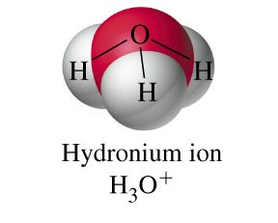
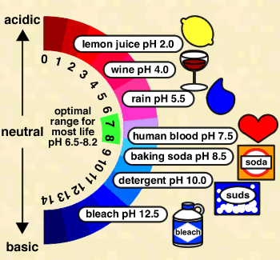

Review of Ch. 5 The Nature and
Properties of Solutions

- Solutions are classified as electrolytes (ionic, acids, bases) if they conduct an electric current or nonelectrolytes (molecular) if they do not conduct.

1. Classify each compound as an electrolyte or nonelectrolyte when dissolved in water.

a) salt water b) ammonia c) vinegar d) drain cleaner

- Ionic compounds dissociate into positive and negative ions when dissolved in water while acids
ionize into H⁺ and a negative ion. Molecular substances disperse and become aqueous if they have high solubility but do not break up into ions!

2. Write dissociation, ionization or dispersal equations for the following substances.
a) aluminium sulfate
b) phosphoric acid
c) sucrose
d) sulfuric acid
e) ammonium hydrogen phosphate

- Aqueous entities are used to represent substances present in a water environment and can be listed using the guidelines below:

- ionic compounds (including bases) with high solubility are represented as ions while those with
low solubility are listed as solid compounds
- molecular substances with high solubility are listed as aqueous compounds while those with
low solubility (fuels) are listed with their original states of matter
- strong acids are listed in their ionized form while weak acids retain their molecular form
- elements (except chlorine) retain their original formulas and states of matter
3. List the chemical formulas for the major entities present in water for the following substances.

a) lead d) ammonia

b) perchloric acid e) oxalic acid

c) sodium nitrate f) calcium hydroxide

- The concentration of a solution is defined as the ratio of the quantity of solute to the quantity of the solution. Concentration can be calculated and reported using the following methods:

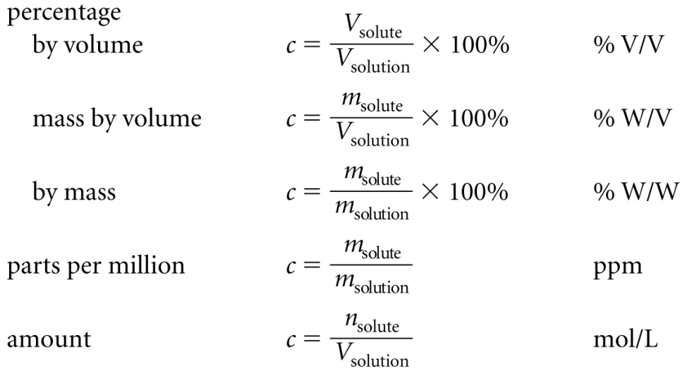

4. Calculate the percentage weight by volume concentration of an intravenous dextrose sugar solution that contains 50 g of dextrose in a 1.00 L bag.

5. Determine the amount concentration of a solution prepared by dissolving 10.0 g of sodium hydroxide in water to make 2.00 L of solution.

- An unknown quantity of solute or quantity of solution can be determined by using a given concentration ratio as a conversion factor.

6. What volume of apple juice with a 12% W/V sugar concentration would contain 9.0 g of sugar?

- 2-step amount concentration calculations involve a mole – mass conversion as well as using the amount concentration relationship.

7. Calculate the amount concentration of a solution prepared by dissolving 8.75 g of
cobalt (III) sulfate in 500 mL of distilled water.

- Ion concentrations in a solution can be determined by using the mole ratio between the compound and the ion from the dissociation equation.

8. Write a dissociation equation and calculate the amount concentration of the cations and anions in a 0.50 mol/L solution of aluminium sulfate.

- Standard solutions are solutions whose concentrations are stable and known precisely. They can be prepared using 2 different methods:

i) Using n = cv and m = nM to determine the mass of a solid chemical to be dissolved in a volumetric flask

ii) Using c_{i} v_{i} = c_{f} v_{f} to determine the volume of concentrated stock solution (v_{i}) to be diluted in a volumetric flask.

9. Determine the mass of potassium hydrogen tartrate, KHC₄H₄O₆(s), needed to prepare a
100.0 mL standard solution with an amount concentration of 0.150 mol/L.

10. If a lab technician needs to prepare 2.00 L of 2.50 mol/L ammonia solution, what volume of 14.8 mol/L concentrated ammonia would be required?

Review of Ch. 6 Acids and Bases

- Conversions between pH of a solution and [H₃O⁺] are carried out using these relationships:

${[H}_{3}O^{+}]= {10}^{-pH}$ and $pH= -log⁡[H_{3}O^{+}]$ * remember sig digs *

11. Determine the pH of lemon juice with a hydronium ion concentration of 7.5 x 10⁻³ mol/L.

12. Calculate the [H₃O⁺] of a cleaning solution whose pH is measured to be 11.562.

- Conversions between pOH of a solution and [OH⁻] are carried out using these relationships:

${[OH}^{-}]= {10}^{-pOH}$ and $pOH= -log⁡[{OH}^{-}]$ * remember sig digs *

13. Determine the hydroxide ion concentration of a cleaning solution whose pOH is measured to be 12.17.

14. Calculate the pOH of a drain cleaner with a hydroxide ion concentration of 4 x 10⁻¹² mol/L.

- The colors produced when solution samples are tested with several acid-base indicators can be used to determine the unknown pH of the solution.

15. Separate samples of an unknown solution turned both methyl orange and bromothymol blue indicators to yellow and turned bromocresol green indicator to blue. Estimate the pH of the unknown solution and calculate the hydronium ion concentration.

- Modified Arrhenius Theory can be used to theoretically define acids and bases.

i) Acids react with water to produce hydronium ions.

ii) Bases either dissociate hydroxide ion directly or react with water to produce hydroxide ion.

16. Write a modified Arrhenius equation to explain why sulfurous acid turns litmus red.

17. Write a modified Arrhenius equation to explain why ammonia turns litmus blue.

- Polyprotic acids and bases can react with water more than once to produce hydronium or hydroxide ions but each successive reaction is weaker than the previous.

18. Show all steps in the reaction of carbonic acid with water to turn litmus red.

19. Show all steps in the reaction of oxalate ion with water to turn litmus blue.

