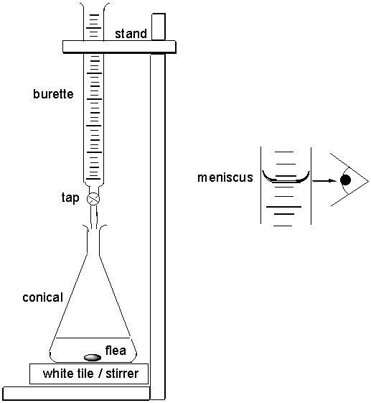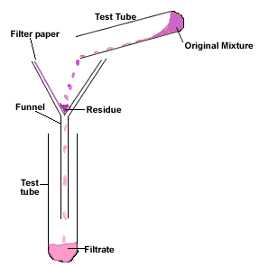

Review of Ch. 7 Stoichiometry

- Net ionic equations can be written by following these steps:

i) write a balanced chemical equation
ii) dissociate or ionize substances with high solubility
iii) cancel out spectator ions on each side of the equation

1. Write a net ionic equation for the reaction of sodium phosphate solution and calcium chloride solution.

- Gravimetric stoichiometry uses the following steps to determine the exact mass of a solid reactant or product in a chemical reaction.

i) write a balanced chemical equation
ii) calculate moles of the given substance using $n= \frac{m}{M}$
iii) multiply the given amount by R/G to get the required amount
iv) calculate the mass of required substance using $m=nM$

2. Predict the mass of carbon dioxide produced when 1.00 kg of ethanol undergoes complete combustion in a car’s engine.

- The percent yield of a reaction is the ratio of the actual or experimental quantity of product obtained to the theoretical quantity of product as predicted by stoichiometry.

$percent yield= \frac{actual yield}{predicted yield}$ x 100

3. In a chemical analysis, 3.00 g of silver nitrate solution was reacted with excess sodium chromate to produce 2.84 g of filtered, dried precipitate. Calculate the percent yield of this reaction.

- Gas stoichiometry uses the following steps to determine the exact mass or volume of a gaseous reactant or product in a chemical reaction.

i) write a balanced chemical equation
ii) calculate moles of the given substance using $n= \frac{m}{M}$ or $n= \frac{V}{V_{m}}$ or $n= \frac{PV}{RT}$
iii) multiply the given amount by R/G to get the required amount
iv) calculate the mass of required substance using $m=nM$ or the volume of required substance using $V=nV_{m}$ or $V=\frac{nRT}{P}$

4. Calculate the volume of hydrogen gas at SATP required to react with an excess of nitrogen gas and produce 2.00 ML of ammonia gas at 10°C and 120 kPa.

- Solution stoichiometry uses the following steps to determine the exact concentraion or volume of a aqueous reactant or product in a chemical reaction.

i) write a balanced chemical equation
ii) calculate moles of the given substance using n = cv
iii) multiply the given amount by R/G to get the required amount
iv) calculate the concentration of the required solution using $c= \frac{n}{v}$ or calculate volume using $v= \frac{n}{c}$

5. What volume of a 0.250 mol/L solution of sodium carbonate solution is required to completely
react with 75.0 mL of a 0.200 mol/L solution of iron(III) chloride?

Review of Ch. 8 Chemical Analysis

- Qualitative analysis to determine the identity of an unknown chemical substance can involve colorimetry – the color of an aqueous solution (P. 11 of Data Book) or the color a sample produces when placed in a flame (P. 6 Data Book).

6. Identify the name and chemical formula of an ionic compound that appears yellow in aqueous solution and produces a yellow flame when burned.

- Quantitative analysis to determine the quantity of a substance present can involve gravimetric analysis – the precipitation of a slightly soluble product in a single or double replacement reaction.

7. Which of the following reagents can be used to precipitate acetate ions from a solution of sodium acetate?

a) AgNO₃(aq) b) BaCl₂(aq) c) CaCl₂(aq) d) Pb(NO₃)₂(aq)
8. What mass of precipitate is produced by the reaction of 25.0 mL of 0.275 mol/L sodium sufide solution with an excess of aluminium nitrate solution?

- Limiting reagents (completely used up) and excess reagents (some left over after reaction) can be determined by calculating the amount in moles of each reactant present and comparing with the mole ratio from the balanced chemical equation.

9. Identify the limiting and excess reagents when 20 g of aluminium chloride and 20 g of sodium hydroxide are allowed to react in a container AND determine the mass of excess reagent left over.

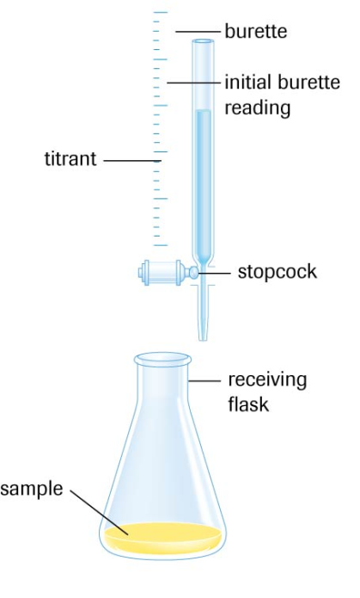
- Quantitative analysis can also involve titration analysis in which a titrant solution from a burette is gradually added to a sample solution in a flask until the endpoint is reached – a sudden change in color or pH of the sample solution.

- The volume of titrant needed to reach the endpoint can be used along with stoichiometry to determine the concentration of the titrant or the sample solution.
10. A 100 mL standard solution of sodium carbonate was prepared in a volumetric flask using
1.74 g of solid. Using methyl orange indicator to detect the second endpoint, 10.00 mL samples of this standard solution were titrated with hydrochloric acid and the results recorded in the following table.

Titration of 10.00 mL samples of Na₂CO₃(aq) with HCl(aq)
Trial | 1 | 2 | 3 | 4
Final burette  reading (mL) | 16.1 | 31.5 | 46.9 | 16.9
Initial burette  reading (mL) | 0.2 | 16.1 | 31.5 | 1.5
Volume of
titrant used (mL)
endpoint  color | red | orange | orange | orange

Determine the amount concentration of the hydrochloric acid solution.

- Titration curves or pH curves are graphs of pH vs volume of titrant used to reach the endpoint.
The curves are useful because:

i) they can be used to identify the sample solution and titrant as an acid or a base.
ii) the volume of titrant needed to reach the equivalence point can be determined.
iii) an acid-base indicator can be chosen whose pH range includes the endpoint pH.
iv) each equivalence point shown on the curve represents one H⁺ reacting completely.
11. For each titration curve shown below:

a) identify the sample solution and titrant as an acid or a base
b) determine the volume of titrant used to reach the equivalence point
c) determine the equivalence point pH
d) suggest a suitable indicator that will change color at the equivalence point

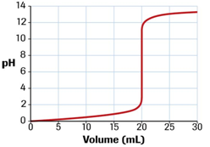

a) sample _______________ titrant _______________
b) equivalence point volume _______________
c) equivalence point pH _______________
d) suitable indicator _______________________________________

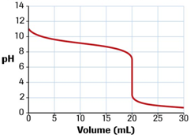

a) sample _______________ titrant _______________
b) equivalence point volume _______________
c) equivalence point pH _______________
d) suitable indicator _______________________________________

